Issues

🦊 What Is Issues?
# Source: AI Source: Provided by: [Data Path: Persons Table -> ID Column: 1, Name_En Column: Motasem Essam] -> From: [ChatGPT] on [2/15/2026]
Issues are a way to track tasks, bugs, feature requests, or discussion points in a repository. They are not part of Git itself, but a feature of platforms like GitHub and GitLab.

Key points
# Source: AI Source: Provided by: [Data Path: Persons Table -> ID Column: 1, Name_En Column: Motasem Essam] -> From: [ChatGPT] on [2/15/2026]
- Purpose
  - Track bugs, enhancements, tasks, or questions related to a project.
  - Acts like a to-do list or ticket system for your code.
- Where they exist
  - Platforms:
    - GitHub → “Issues” tab
    - GitLab → “Issues” section
  - Not part of core Git commands
- Who can use them
  - Team members or contributors
  - Public contributors (if repo is public)

What an Issue contains
# Source: AI Source: Provided by: [Data Path: Persons Table -> ID Column: 1, Name_En Column: Motasem Essam] -> From: [ChatGPT] on [2/15/2026]
- Title → Short description of the problem or task
- Description → Detailed explanation, steps, ScreenShot
- Labels → Categorize issue (bug, enhancement, help wanted, etc.)
- Assignees → Who is responsible
- Comments → Discussion between team members
- Status → Open / Closed
- Linked Pull Request / Merge Request → Shows which PR/MR addresses the issue

Example
# Source: AI Source: Provided by: [Data Path: Persons Table -> ID Column: 1, Name_En Column: Motasem Essam] -> From: [ChatGPT] on [2/15/2026]
Issue:
- Title: “Login button not working on mobile”
- Description: Steps to reproduce, expected behavior, ScreenShot
- Label: bug
- Assignee: developer
- Status: open → closed after fix merged

Benefits of Issues
# Source: AI Source: Provided by: [Data Path: Persons Table -> ID Column: 1, Name_En Column: Motasem Essam] -> From: [ChatGPT] on [2/15/2026]
- Keeps track of bugs and features
- Improves team collaboration
- Links work to commits, branches, and PRs/MRs
- Helps in project planning and tracking

Commands to manage issues from CLI
# Source: AI Source: Provided by: [Data Path: Persons Table -> ID Column: 1, Name_En Column: Motasem Essam] -> From: [ChatGPT] on [2/15/2026]
GitHub CLI (gh):
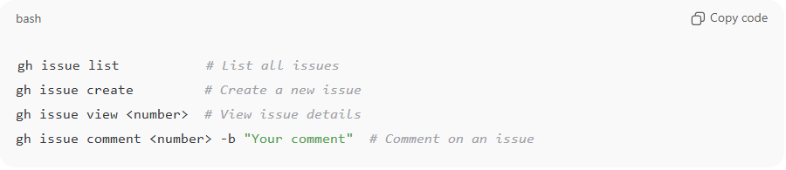
gh issue list # List all issues
gh issue create # Create a new issue
gh issue view <number> # View issue details
gh issue comment <number> -b "Your comment" # Comment on an issue
GitLab CLI (glab):
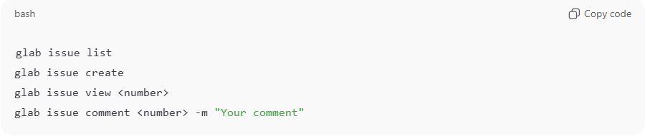
glab issue list
glab issue create
glab issue view <number>
glab issue comment <number> -m "Your comment"

💡 Memory trick:
# Source: AI Source: Provided by: [Data Path: Persons Table -> ID Column: 1, Name_En Column: Motasem Essam] -> From: [ChatGPT] on [2/15/2026]
Issues = project’s task tracker / bug tracker inside GitHub or GitLab → not Git itself.

